**EXCEL ASSIGNMENT-2**

**Q1.** The blank value using countif-sumif

Step-1. Formula used to find the answers as shown below.

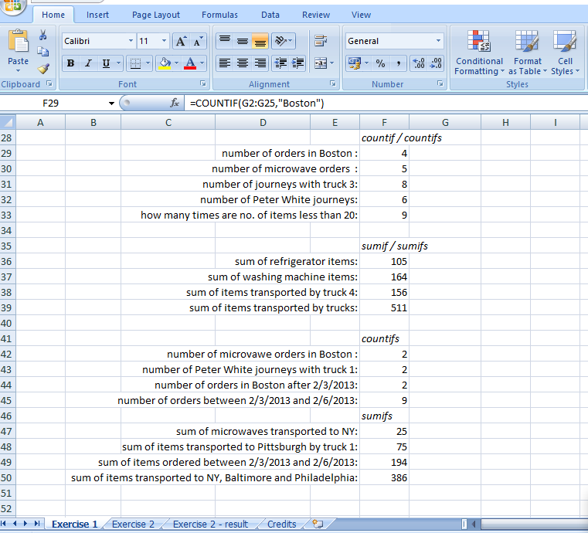

Step-2. Using the following formula to fill up the blank cells in the given exercise

